**ECE 1245 Final Project: Light Sensor For Bathroom**

By Hoc Nguy

**Proposed Project Idea**

* Light sensor for bathroom:
* If the bathroom is dark (light sensor) and a person walks in (temperature sensor). The light will turn on.
* If the bathroom’s light is off (ON) but there is no present of a person (OFF), the light sensor is still turned off (OFF)
* If the person is in the bathroom (ON) with the light on (OFF), the light sensor is still turned off.
* If neither the light is off (OFF) nor the person is in the bathroom (OFF), the light is turned off. (OFF)

**Create Block Diagram**

This block diagram shows boxes with arrows between them for the functional part of my light sensor system. The block diagram is divided in 4 phases: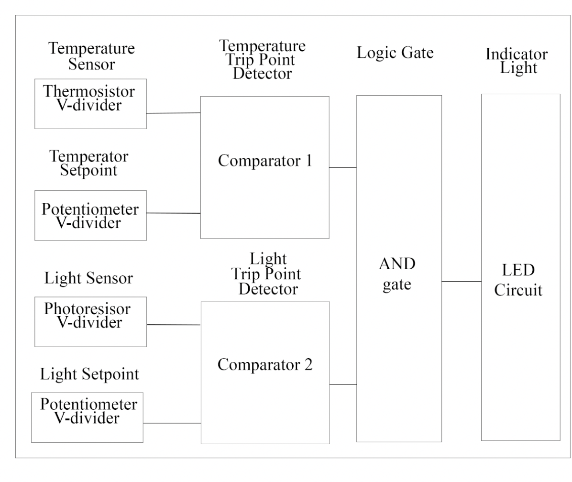

* Sensor phases: This phase contains the sensors (light and temperature) and their respective set point. The light sensor detects the ambient light intensity, while the temperature sensor detects the presence of a person.
* Comparator phases: This phase represents the trip point detectors. The comparators determine whether the light and temperature reading exceed or fall below their relative set point.
* Logic phases: This phase evaluates whether both conditions (light and temperature) meet the requirements. The logic gate will ensure the LED turns on when both conditions are sanctified.
* LED phases: Once the logic gates confirm both conditions are met, the LED will turn on.